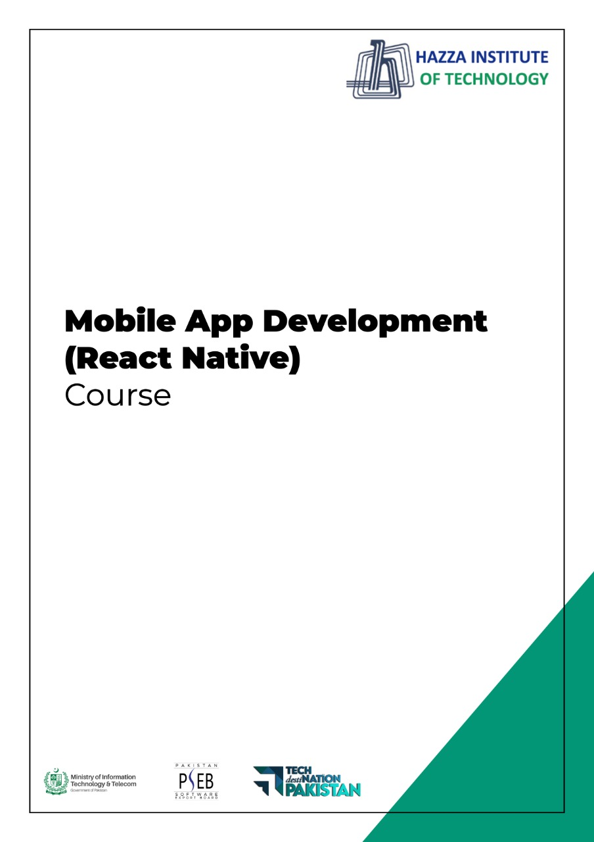
(Flutter)
Flutter Lab 13

Total Time:
3 hours (sessions-1)

Pre-Lab Activities:
  - Student must complete previous labs

Learning Outcomes:
- Demonstrate the knowledge of Flutter UIs.
- In this lab we will be creating a complete app using sqlite database

Student Activities:
  - Practicing database concepts

Lab Tasks:
  - Create a Flutter UI accoridng to below figures

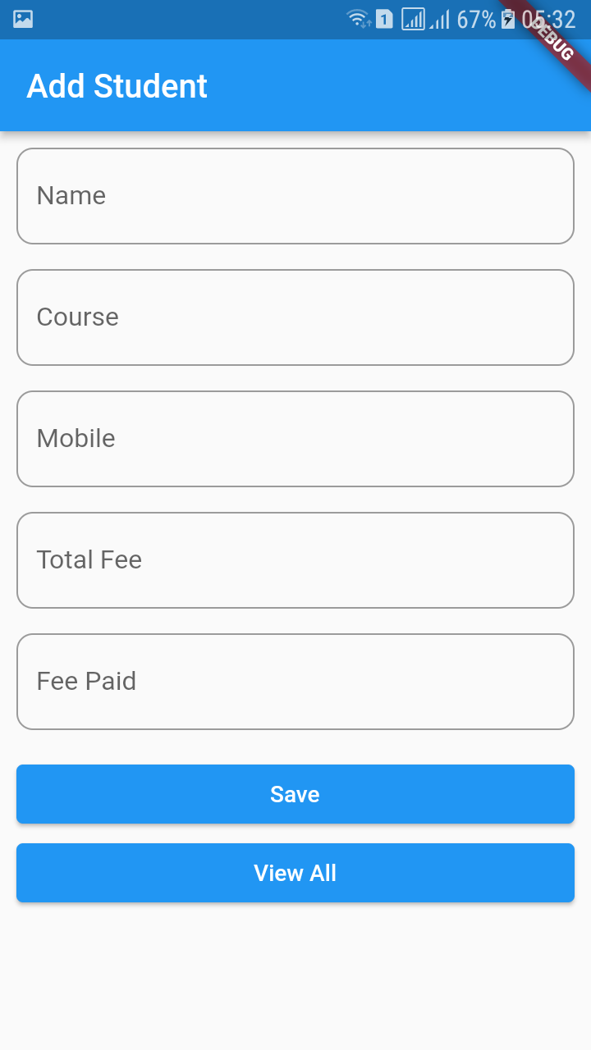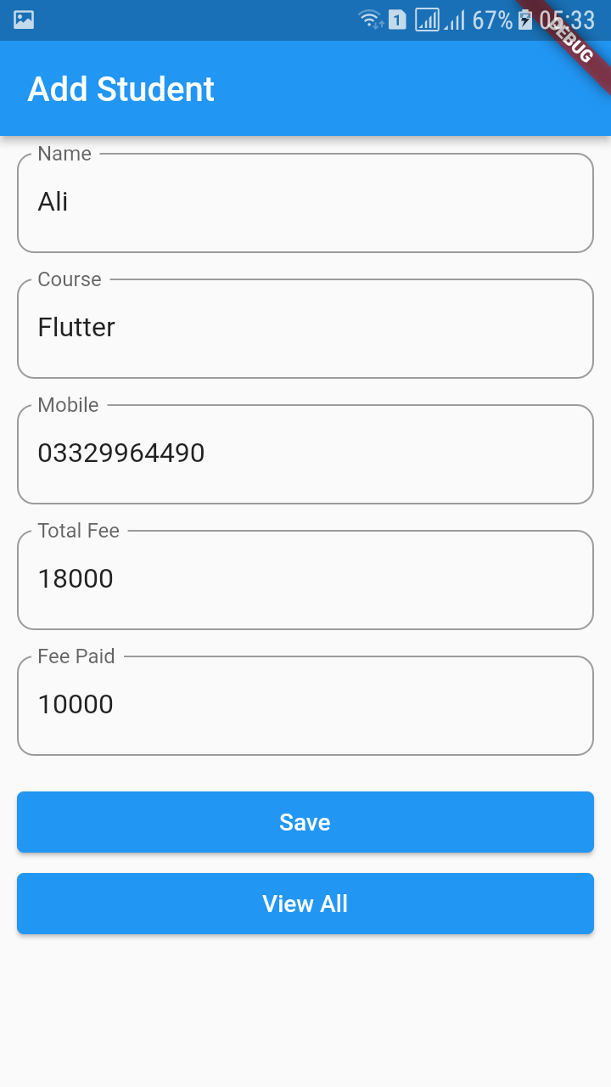

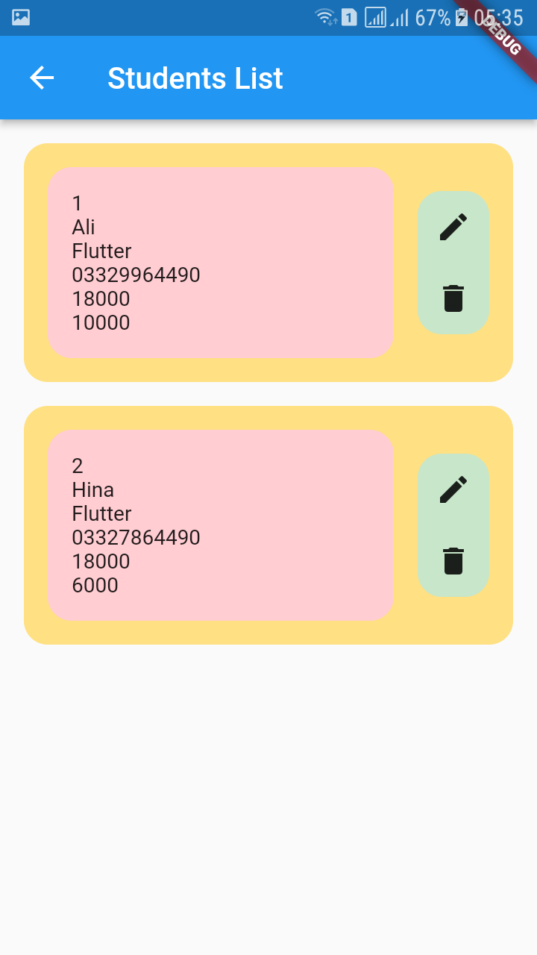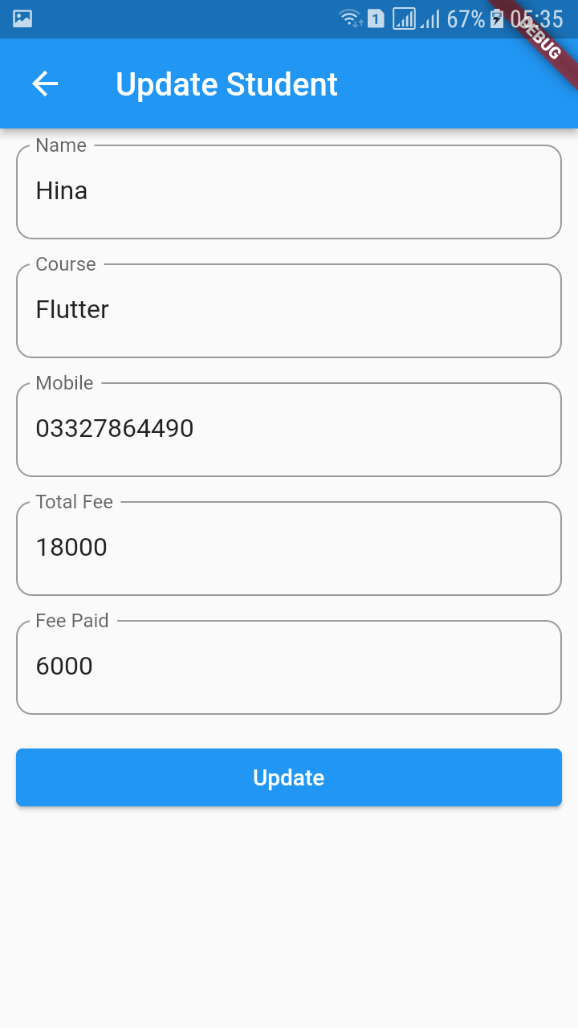

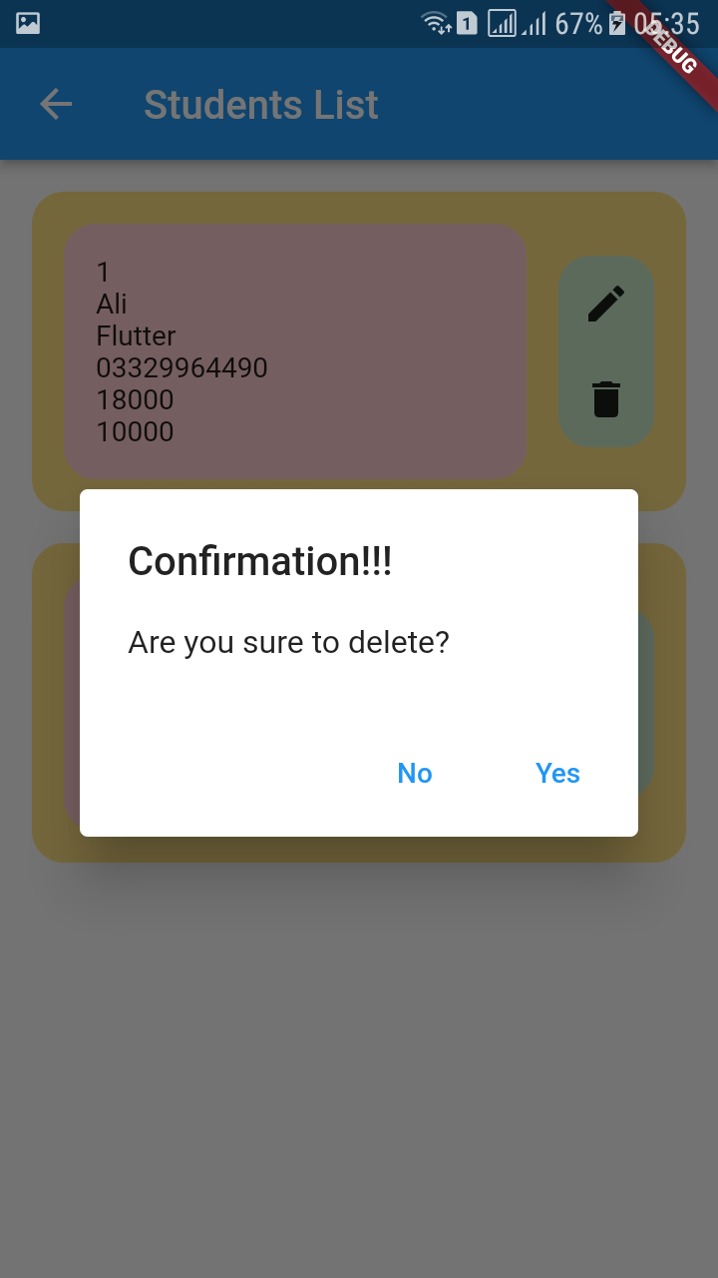

Project Structure
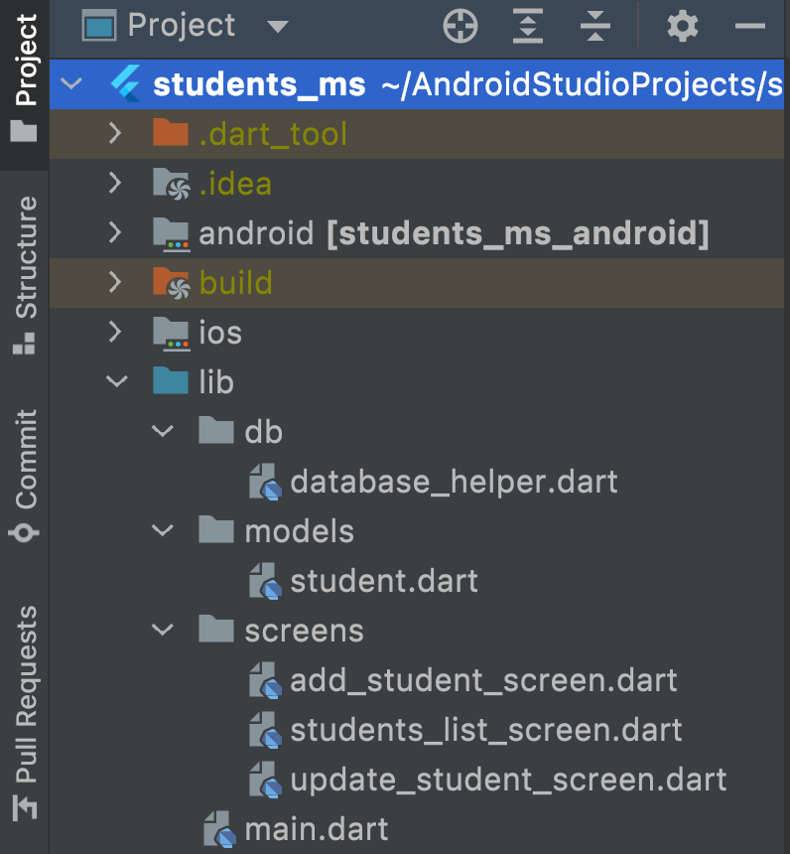

Dependencies
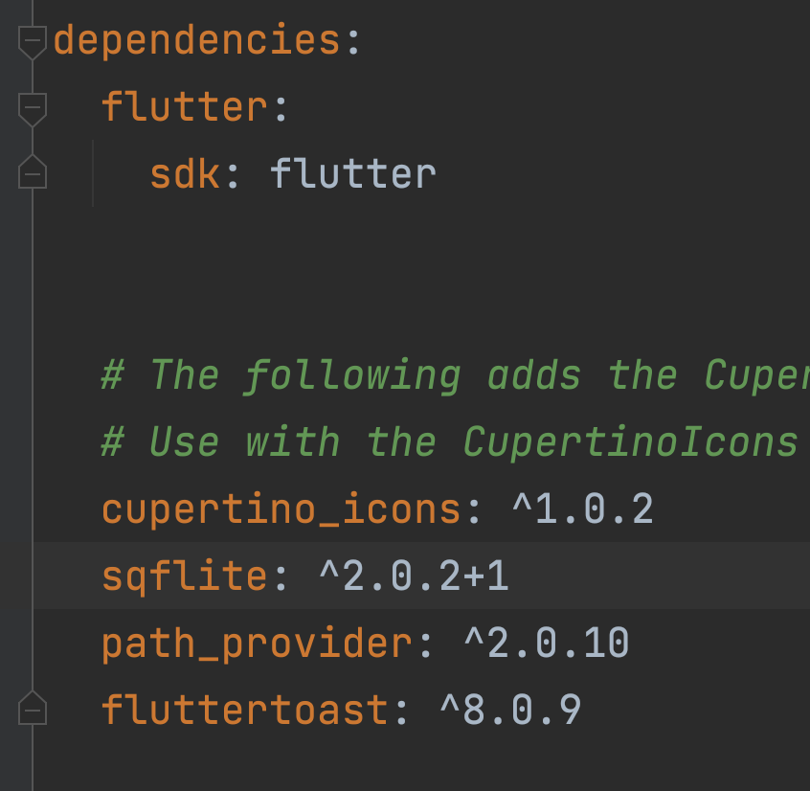

Lab Solutions:

CODE: Model
class Student {
late int? id;
late String name;
late String course;
late String mobile;
late int totalFee;
late int feePaid;

Student({
this.id,
required this.name,
required this.course,
required this.mobile,
required this.totalFee,
required this.feePaid,
});

// function to convert object to map
Map<String, dynamic> toMap() {
Map<String, dynamic> map = {};

map['id'] = id;
map['name'] = name;
map['course'] = course;
map['mobile'] = mobile;
map['totalFee'] = totalFee;
map['feePaid'] = feePaid;

return map;
}

// function to convert map to object
// named constructor

Student.fromMap( Map<String, dynamic> map) {
id = map['id'];
name = map['name'];
course = map['course'];
mobile = map['mobile'];
totalFee = map['totalFee'];
feePaid = map['feePaid'];
}

}

DatabaseHelper
import 'dart:io';

import 'package:path_provider/path_provider.dart';
import 'package:sqflite/sqflite.dart';

import '../models/student.dart';

class DatabaseHelper {
// database
DatabaseHelper._privateConstructor(); // Name constructor to create instance of database
static final DatabaseHelper instance = DatabaseHelper._privateConstructor();

static Database? _database;

// getter for database

Future<Database> get database async {
_database ??= await initializeDatabase();
return _database!;
}

Future<Database> initializeDatabase() async {
// Get the directory path for both Android and iOS
// to store database

Directory directory = await getApplicationDocumentsDirectory();
String path = '${directory.path}/students.db';

// open/ create database at a given path
var studentsDatabase = await openDatabase(
path,
version: 1,
onCreate: _createDb,
);

return studentsDatabase;
}

void _createDb(Database db, int newVersion) async {
await db.execute('''Create TABLE tbl_student (
id INTEGER PRIMARY KEY AUTOINCREMENT,
name TEXT,
course TEXT,
mobile TEXT,
totalFee INTEGER,
feePaid INTEGER )

''');
}

// insert
Future<int> insertStudent(Student s) async {
// add student to table

Database db = await instance.database;
//int result = await db.rawInsert('INSERT INTO tbl_student (name, course, mobile, totalFee, feePaid) VALUES (?, ?, ?, ?, ?)', [s.name, s.course, s.mobile, s.totalFee, s.feePaid]);

int result = await db.insert('tbl_student', s.toMap());

return result;
}

// read

Future<List<Student>> getAllStudents() async {
List<Student> students = [];

// read data from table
Database db = await instance.database;
//db.rawQuery('SELECT * from tbl_student');

List<Map<String, dynamic>> listMap = await db.query('tbl_student');

for (var studentMap in listMap) {
Student s = Student.fromMap(studentMap);
students.add(s);
}

await Future.delayed(const Duration(seconds: 3));
return students;
}

// update
Future<int> updateStudent(Student s) async {
Database db = await instance.database;
/*
int result = await db.rawUpdate(
'UPDATE tbl_student set name=?, course=?, mobile=?, totalFee=?, feePaid=? where id=?',
[s.name, s.course, s.mobile, s.totalFee, s.feePaid, s.id]);
*/
int result = await db.update('tbl_student', s.toMap(), where: 'id=?', whereArgs: [s.id]);
return result;
}

// delete

Future<int> deleteStudent(int id) async {
Database db = await instance.database;
//int result = await db.rawDelete('DELETE from tbl_student where id=?', [id] );

int result = await db.delete('tbl_student', where: 'id=?', whereArgs: [id]);
return result;
}
}

Add Student Screen
import 'package:flutter/material.dart';
import 'package:fluttertoast/fluttertoast.dart';
import 'package:students_ms/db/database_helper.dart';
import 'package:students_ms/models/student.dart';
import 'package:students_ms/screens/students_list_screen.dart';

class AddStudentScreen extends StatefulWidget {
const AddStudentScreen({Key? key}) : super(key: key);

@override
State<AddStudentScreen> createState() => _AddStudentScreenState();
}

class _AddStudentScreenState extends State<AddStudentScreen> {
var formKey = GlobalKey<FormState>();

late String name, course, mobile, totalFee, feePaid;

@override
Widget build(BuildContext context) {
return Scaffold(
appBar: AppBar(
title: const Text('Add Student'),
),
body: Padding(
padding: const EdgeInsets.all(10),
child: SingleChildScrollView(
child: Form(
key: formKey,
child: Column(
crossAxisAlignment: CrossAxisAlignment.stretch,
children: [
TextFormField(
decoration: InputDecoration(
hintText: 'Name',
labelText: 'Name',
border: OutlineInputBorder(
borderRadius: BorderRadius.circular(10.0))),
validator: (String? text) {
if (text == null || text.isEmpty) {
return 'Please provide name';
}

name = text;
return null;
},
),
const SizedBox(
height: 15,
),
TextFormField(
decoration: InputDecoration(
hintText: 'Course',
labelText: 'Course',
border: OutlineInputBorder(
borderRadius: BorderRadius.circular(10.0))),
validator: (String? text) {
if (text == null || text.isEmpty) {
return 'Please provide course';
}

course = text;
return null;
},
),
const SizedBox(
height: 15,
),
TextFormField(
keyboardType: TextInputType.number,
decoration: InputDecoration(
hintText: 'Mobile',
labelText: 'Mobile',
border: OutlineInputBorder(
borderRadius: BorderRadius.circular(10.0))),
validator: (String? text) {
if (text == null || text.isEmpty) {
return 'Please provide mobile';
}

mobile = text;
return null;
},
),
const SizedBox(
height: 15,
),
TextFormField(
keyboardType: TextInputType.number,
decoration: InputDecoration(
hintText: 'Total Fee',
labelText: 'Total Fee',
border: OutlineInputBorder(
borderRadius: BorderRadius.circular(10.0))),
validator: (String? text) {
if (text == null || text.isEmpty) {
return 'Please provide name';
}

totalFee = text;
return null;
},
),
const SizedBox(
height: 15,
),
TextFormField(
keyboardType: TextInputType.number,
decoration: InputDecoration(
hintText: 'Fee Paid',
labelText: 'Fee Paid',
border: OutlineInputBorder(
borderRadius: BorderRadius.circular(10.0))),
validator: (String? text) {
if (text == null || text.isEmpty) {
return 'Please provide name';
}

feePaid = text;
return null;
},
),
const SizedBox(
height: 15,
),
ElevatedButton(
onPressed: () async {
if (formKey.currentState!.validate()) {
// save record in DB Table
// create a student object
Student s = Student(
name: name,
course: course,
mobile: mobile,
totalFee: int.parse(totalFee),
feePaid: int.parse(feePaid),
);

int result = await DatabaseHelper.instance.insertStudent(s);

if( result > 0 ){
Fluttertoast.showToast(msg: "Record Saved", backgroundColor: Colors.green);
}else{
Fluttertoast.showToast(msg: "Record Failed", backgroundColor: Colors.red);

}
}
},
child: const Text('Save')),
ElevatedButton(
onPressed: () {
Navigator.of(context)
.push(MaterialPageRoute(builder: (_) {
return const StudentsListScreen();
}));
},
child: const Text('View All')),
],
),
),
),
),
);
}
}

StudentsList Screen
import 'package:flutter/material.dart';
import 'package:fluttertoast/fluttertoast.dart';
import 'package:students_ms/db/database_helper.dart';
import 'package:students_ms/models/student.dart';
import 'package:students_ms/screens/update_student_screen.dart';

class StudentsListScreen extends StatefulWidget {
const StudentsListScreen({Key? key}) : super(key: key);

@override
State<StudentsListScreen> createState() => _StudentsListScreenState();
}

class _StudentsListScreenState extends State<StudentsListScreen> {
@override
Widget build(BuildContext context) {
return Scaffold(
appBar: AppBar(
title: const Text("Students List"),
),
body: FutureBuilder<List<Student>>(
future: DatabaseHelper.instance.getAllStudents(),
builder: (BuildContext context, AsyncSnapshot<List<Student>> snapshot){

if( !snapshot.hasData){
return const Center(child: CircularProgressIndicator());
}else {

if( snapshot.data!.isEmpty){
return const Center(child: Text('No Records Found'));

}else{

List<Student> students = snapshot.data!;

return Padding(
padding: const EdgeInsets.all(16.0),
child: ListView.builder(
itemCount: students.length,
itemBuilder: (context, index){

Student s = students[index];

return Container(
margin: const EdgeInsets.only(bottom: 16.0),
padding: const EdgeInsets.all(16.0),
decoration: BoxDecoration(
color: Colors.amber[200],
borderRadius: BorderRadius.circular(16.0),
),
child: Row(
children: [
Expanded(
child: Container(
padding: const EdgeInsets.all(16.0),
decoration: BoxDecoration(
color: Colors.red[100],
borderRadius: BorderRadius.circular(16.0)
),
child: Column(
crossAxisAlignment: CrossAxisAlignment.start,
children: [
Text(s.id.toString()),

Text(s.name),
Text(s.course),
Text(s.mobile),
Text(s.totalFee.toString()),
Text(s.feePaid.toString())
],
),
),
),
const SizedBox(width: 16.0,),
Container(
decoration: BoxDecoration(
color: Colors.green[100],
borderRadius: BorderRadius.circular(16.0)
),
child: Column(
children: [
IconButton(onPressed: () async{
String result = await Navigator.of(context).push(MaterialPageRoute(builder: (context){
return UpdateStudentScreen(student: s);
}));

if( result == 'done'){
setState((){});
}

}, icon: const Icon(Icons.edit)),
IconButton(onPressed: (){

showDialog(
barrierDismissible: false,
context: context, builder: (context){
return AlertDialog(
title: const Text('Confirmation!!!'),
content: const Text('Are you sure to delete?'),
actions: [
TextButton(onPressed: (){
Navigator.of(context).pop();
}, child: const Text('No')),
TextButton(onPressed: () async{
Navigator.of(context).pop();

// delete student

int result = await DatabaseHelper.instance.deleteStudent(s.id!);

if( result > 0 ){
Fluttertoast.showToast(msg: 'RECORD DELETED');
setState((){});
// build function will be called
}

}, child: const Text('Yes')),

],
);
});

}, icon: const Icon(Icons.delete)),

],
),
)
],
),
);
}),
);
}

}

}),
);
}
}

Update Student Screen
import 'package:flutter/material.dart';
import 'package:fluttertoast/fluttertoast.dart';
import 'package:students_ms/db/database_helper.dart';

import '../models/student.dart';

class UpdateStudentScreen extends StatefulWidget {
final Student student;
const UpdateStudentScreen({Key? key, required this.student}) : super(key: key);

@override
State<UpdateStudentScreen> createState() => _UpdateStudentScreenState();
}

class _UpdateStudentScreenState extends State<UpdateStudentScreen> {

var formKey = GlobalKey<FormState>();
late String name, course, mobile, totalFee, feePaid;

@override
void initState() {
super.initState();
}

@override
Widget build(BuildContext context) {
return Scaffold(
appBar: AppBar(
title: const Text('Update Student'),
),
body: Padding(
padding: const EdgeInsets.all(10),
child: SingleChildScrollView(
child: Form(
key: formKey,
child: Column(
crossAxisAlignment: CrossAxisAlignment.stretch,
children: [
TextFormField(

initialValue: widget.student.name,
decoration: InputDecoration(
hintText: 'Name',
labelText: 'Name',
border: OutlineInputBorder(
borderRadius: BorderRadius.circular(10.0)
)
),
validator: ( String? text){
if( text == null || text.isEmpty){
return 'Please provide name';
}

name = text;
return null;
},
),
const SizedBox(height: 15,),
TextFormField(
initialValue: widget.student.course,
decoration: InputDecoration(
hintText: 'Course',
labelText: 'Course',
border: OutlineInputBorder(
borderRadius: BorderRadius.circular(10.0)
)
),
validator: ( String? text){
if( text == null || text.isEmpty){
return 'Please provide course';
}

course = text;
return null;
},
),
const SizedBox(height: 15,),
TextFormField(
keyboardType: TextInputType.number,
initialValue: widget.student.mobile,
decoration: InputDecoration(
hintText: 'Mobile',
labelText: 'Mobile',
border: OutlineInputBorder(
borderRadius: BorderRadius.circular(10.0)
)
),
validator: ( String? text){
if( text == null || text.isEmpty){
return 'Please provide mobile';
}

mobile = text;
return null;
},
),
const SizedBox(height: 15,),
TextFormField(
keyboardType: TextInputType.number,
initialValue: widget.student.totalFee.toString(),
decoration: InputDecoration(
hintText: 'Total Fee',
labelText: 'Total Fee',
border: OutlineInputBorder(
borderRadius: BorderRadius.circular(10.0)
)
),
validator: ( String? text){
if( text == null || text.isEmpty){
return 'Please provide name';
}

totalFee = text;
return null;
},
),
const SizedBox(height: 15,),
TextFormField(
keyboardType: TextInputType.number,
initialValue: '${widget.student.feePaid}',
decoration: InputDecoration(
hintText: 'Fee Paid',
labelText: 'Fee Paid',
border: OutlineInputBorder(
borderRadius: BorderRadius.circular(10.0)
)
),
validator: ( String? text){
if( text == null || text.isEmpty){
return 'Please provide name';
}

feePaid = text;
return null;
},
),
const SizedBox(height: 15,),

ElevatedButton(onPressed: () async{
if( formKey.currentState!.validate()){
// update record in DB Table

Student s = Student(
id: widget.student.id,
name: name,
course: course,
mobile: mobile,
totalFee: int.parse(totalFee),
feePaid: int.parse(feePaid),
);

int result = await DatabaseHelper.instance.updateStudent(s);

if( result > 0 ){
Fluttertoast.showToast(msg: "Record Update", backgroundColor: Colors.green);
Navigator.pop(context, 'done');

}else{
Fluttertoast.showToast(msg: "Updating Failed", backgroundColor: Colors.red);

}
}

}, child: const Text('Update')),

],
),
),
),
),
);
}
}
Complete Source Code
https://github.com/abidroid/students_ms

